IFG Adventure 3rd Year

Term Three - Week Four Mission Possible Spiritual
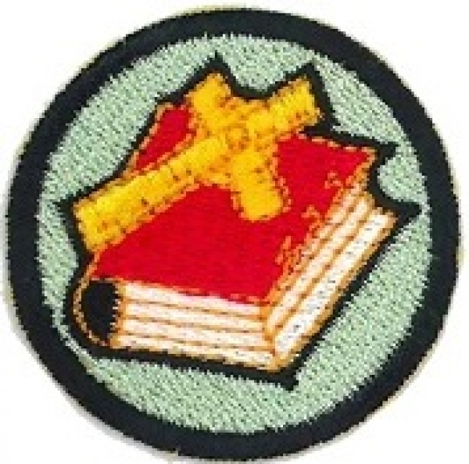
Aim:
Over the next three weeks we will unpack “The Great Commission”, the instruction given by Jesus to His followers to be missionaries.

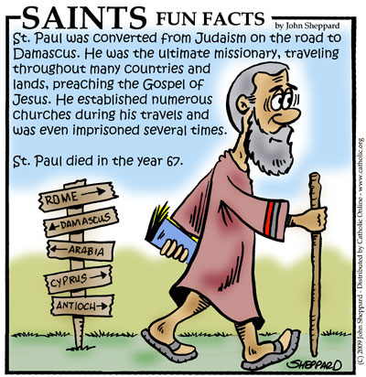
Objectives:
- To explore the which, what, where, when, who and how of missionaries by looking at three different examples.

Equipment Needed:
- Bibles – one per group of five girls
- Materials for making model or mural of Paul’s journeys eg old sheet, newsprint, sand, glue, paint, paint brushes, different coloured string or wool, modelling clay etc
- Set of five different coloured buttons and set of question cards per group of five girls

SetUp:
Commence the formal part of the evening with roll call etc.

Devotions:
(As this badge subject is a spiritual one, there are no separate devotions for the next three weeks).

Mission Possible
Coaches Tip:
You may know of a suitable person in your church or area to invite in for the next three weeks to lead the study on missionaries. This person may have had (recent) personal experience as a missionary or they may be part of a mission’s team who supports the people in the field.

Lead a discussion to find out what the girls know about missionaries and what do they do. Do they know anyone who is or has been a missionary?

“What is The Great Commission?

Matthew 28:18-20
Then Jesus came to them and said, "All authority in heaven and on earth has been given to me. Therefore go and make disciples of all nations, baptizing them in the name of the Father and of the Son and of the Holy Spirit, and teaching them to obey everything I have commanded you. And surely I am with you always, to the very end of the age." (NIV)
OR

¹⁸⁻²⁰Jesus, undeterred, went right ahead and gave his charge: "God authorized and commanded me to commission you: Go out and train everyone you meet, far and near, in this way of life, marking them by baptism in the threefold name: Father, Son, and Holy Spirit. Then instruct them in the practice of all I have commanded you. I'll be with you as you do this, day after day after day, right up to the end of the age." (The Message)
This part of the Bible is known as The Great Commission. It is the last recorded thing Jesus told his disciples, so it is very special to His followers. Missionary work is based on these verses, especially to different cultures as the instruction was Go ye into all the world. (KJV).
Through the generations Christians have followed this command. As many have said, it's not "The Great Suggestion." No, the Lord has commanded us to go out and put our faith into action.

We are going to have a look at three different missionaries in three different times over the next three weeks – one from a very long time ago – in fact he was the very first missionary of all – one very brave young woman who went to China all by herself in the 1920’s and a modern day missionary – someone just like me or (name your other leaders here)”

Paul – The Ultimate Missionary
Introduce the girls to Paul by reading Acts 9:1-31.
Isn’t it interesting that the early church's greatest missionary started out as its greatest enemy. This is the story of Saul--later renamed Paul--and the encounter with Jesus that led him to stop persecuting the church... and join it.

An illustrated story of Paul’s Amazing Travels can be found at:
http://www.bibleforchildren.org/PDFs/english/Pauls%20Amazing%20Travels%20English.pdf

Here is a list of the Books in the New Testament written by Paul. Show the girls in your bible the New Testament and then the Books in it that were written by Paul – a big chunk of it. Explain that these were letters that Paul wrote to Christians in some of the places that he visited as a missionary.

First Thessalonians | 52 AD
Second Thessalonians | 52 AD
First Corinthians | 57 AD
Second Corinthians | 57 AD
Galatians | 55-57 AD
Romans | 57-58 AD
Ephesians | 62 AD
Philippians | 62 AD
Colossians | 62 AD
Philemon | 63 AD
Hebrews | 64-65 AD
Titus | 64-65 AD
First Timothy | 64-65 AD
Second Timothy | 66-67 AD

Here are the dates of Paul’s journeys as near as we can tell

Paul at Damascus | 37-40 AD
First Journey | 45-47 AD
Second Journey | 51-53 AD
Third Journey | 54-58 AD
Imprisonment in Judea | 58-60 AD
Voyage to Rome | 60-61 AD
Imprisonment in Rome | 61-63 AD
Post-Imprisonment Journeys | 63-67 AD

Copy the map on the next page – one for each group

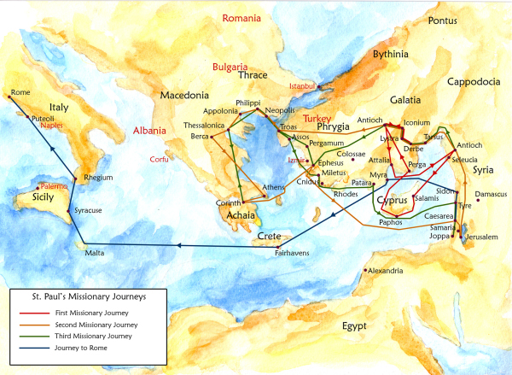

Prayer

Activities:
One
Gather girls into groups of no more than five and using the map of Paul’s journeys provided as a guide, use whatever materials you have available to make a model or paint a mural. Remember to put down a drop cloth or lots of newspaper to protect the surroundings.
Two
Give each girl in the group a different coloured button. Each girl in turn takes a card from the deck and puts her button down on the map near where the described happening took place. The girl with her button closest to the place described is the winner.

Copy onto cards for Activity Two:
I lost my sight while travelling to this place
I was shipwrecked on this island
My letter to the Galatians was written to the people living at this place
I wrote two letters to the people living here (two right answers)
My life ended at this place
Answers:
Damascus
Malta
Galatia
Corinth or Thessalonica
Rome

Game
Notices and Home Time:

End evening with a prayer

